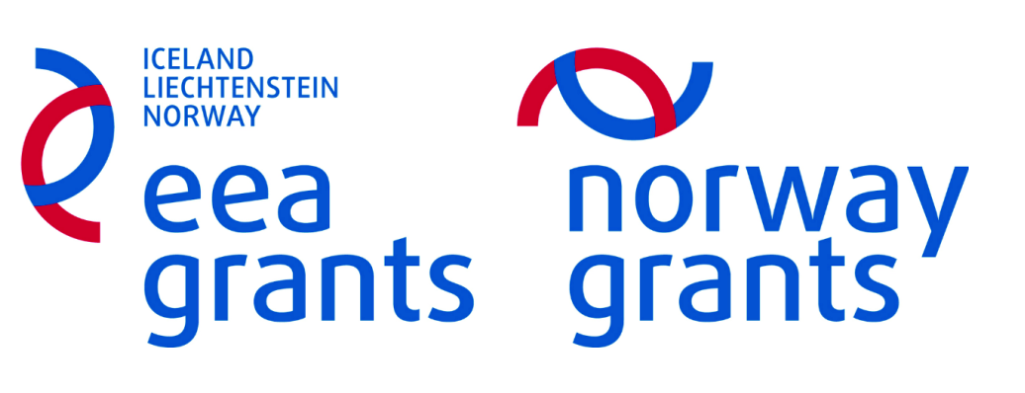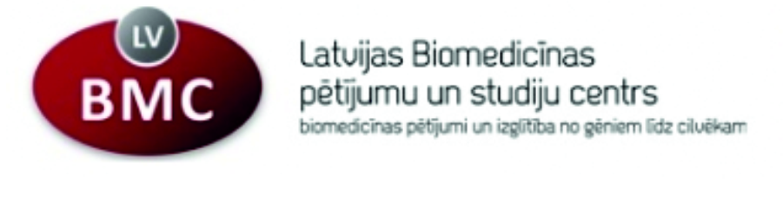
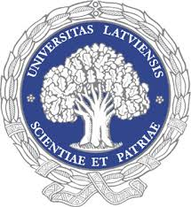

Seminar

Novel approaches in cancer treatment
Latvian Biomedical Research and Study Centre
Rīga, Rātsupītes str.1.k.1.

May 31, 2016

10:00 – 11:00
Resent advances in alphavirus-based cancer vaccines, Anna Zajakina (Latvian Biomedical Research and Study Centre)

A novel vaccine strategy based on the autophagy pathway, Inger Øynebråten (Oslo University Hospital)

11:00 – 11:15
Coffee break & snacks

11:15 – 12:15

Cancer immunotherapy by targeting tumor-infiltrating macrophages, Alexandre Corthay (Oslo University Hospital)

Amphiphilic multimodal lipid type compounds on the basis of heterocycles as theranostic agents for cancer treatment, Gunārs Duburs (Latvian Institute of Organic Synthesis)

12:15
Coffee break & snacks
Discussion

